GPS Receiver
# Source: AI Source: Provided by: [Data Path: Persons Table -> ID Column: 1, Name_En Column: Motasem Essam] -> From: [ChatGPT] on [7/17/2026]
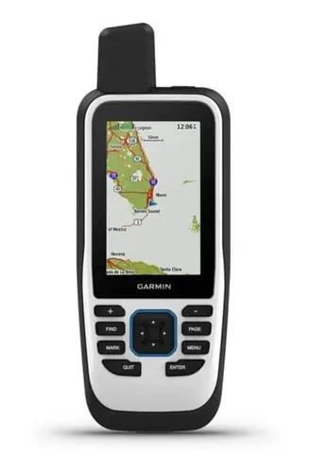
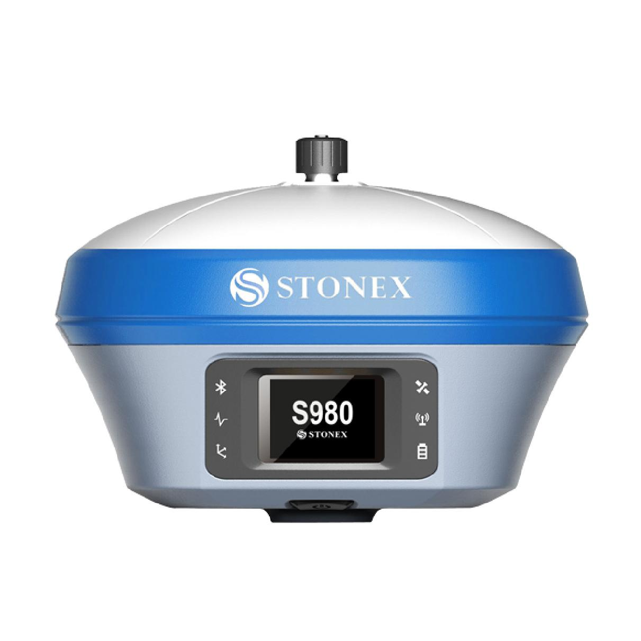
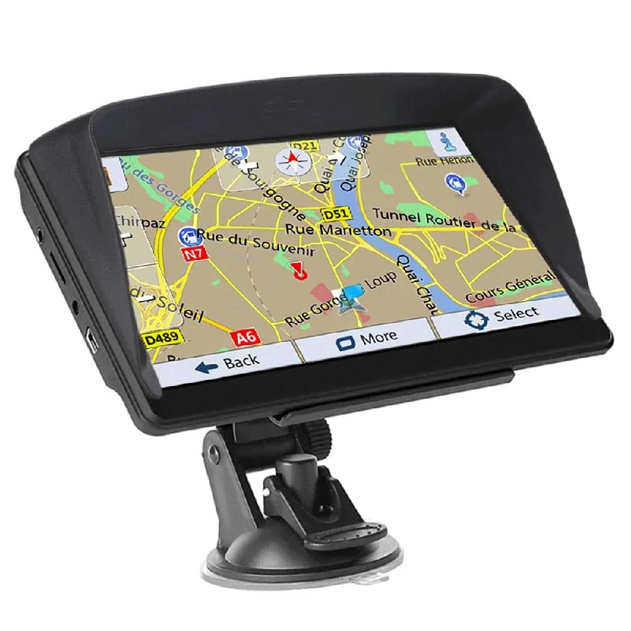
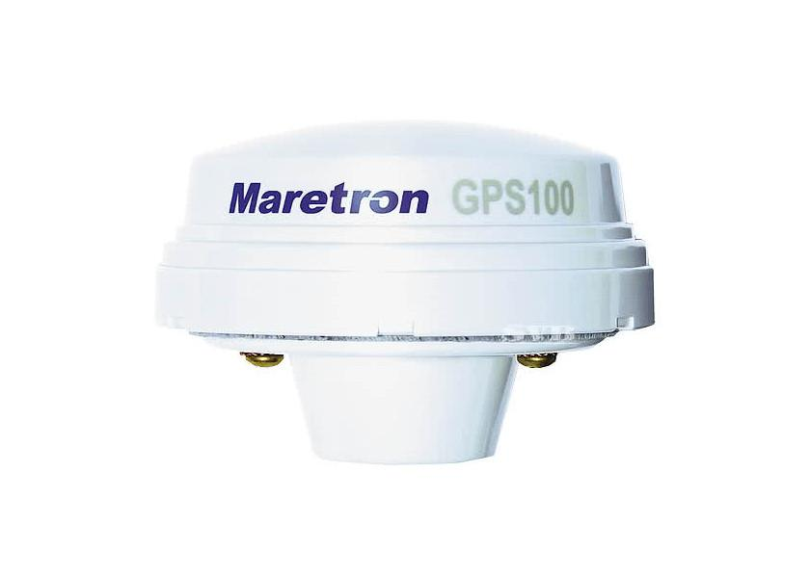
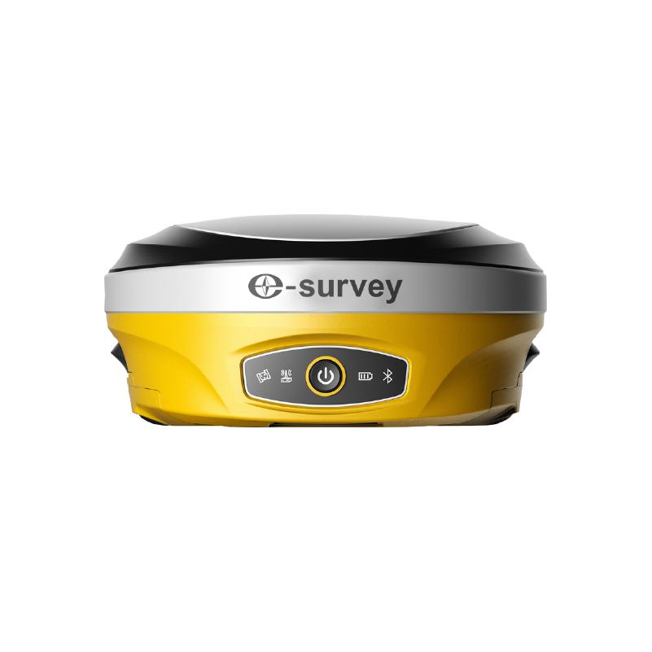
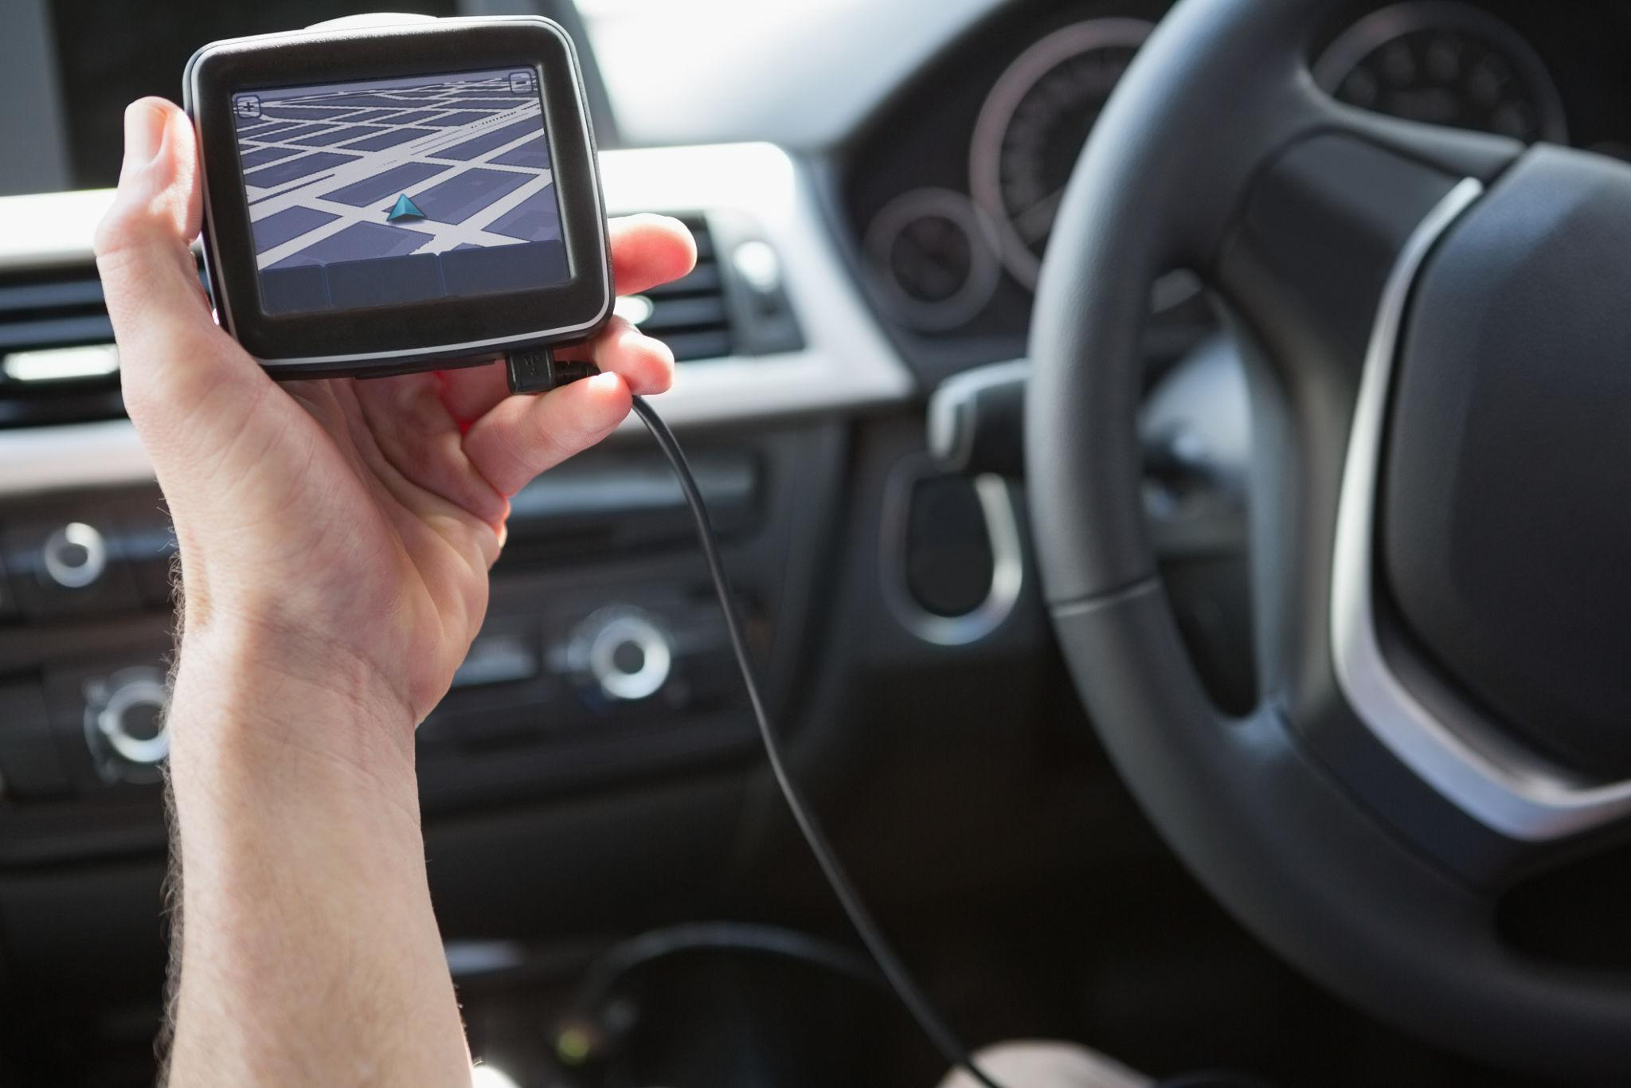
A GPS Receiver (Global Positioning System Receiver) is an electronic device that determines its position, movement, and speed by receiving signals from satellites orbiting the Earth. It calculates speed based on changes in position over time or by using the Doppler shift of satellite signals.
Modern GPS receivers often support multiple satellite navigation systems, collectively known as GNSS (Global Navigation Satellite Systems), including GPS (USA), GLONASS (Russia), Galileo (Europe), and BeiDou (China).

Definition
# Source: AI Source: Provided by: [Data Path: Persons Table -> ID Column: 1, Name_En Column: Motasem Essam] -> From: [ChatGPT] on [7/17/2026]
A GPS Receiver is an electronic navigation instrument that receives signals from navigation satellites to determine location, speed, direction, and time.

Purpose
# Source: AI Source: Provided by: [Data Path: Persons Table -> ID Column: 1, Name_En Column: Motasem Essam] -> From: [ChatGPT] on [7/17/2026]
A GPS receiver is used to:
- Measure ground speed.
- Determine geographic position.
- Track movement.
- Navigate routes.
- Record travel distance.
- Support surveying and mapping.

Principle of Operation
# Source: AI Source: Provided by: [Data Path: Persons Table -> ID Column: 1, Name_En Column: Motasem Essam] -> From: [ChatGPT] on [7/17/2026]
A GPS receiver:
- Receives signals from multiple satellites.
- Calculates its position using trilateration.
- Determines speed by measuring position changes over time or Doppler frequency shifts.

Main Components
# Source: AI Source: Provided by: [Data Path: Persons Table -> ID Column: 1, Name_En Column: Motasem Essam] -> From: [ChatGPT] on [7/17/2026]
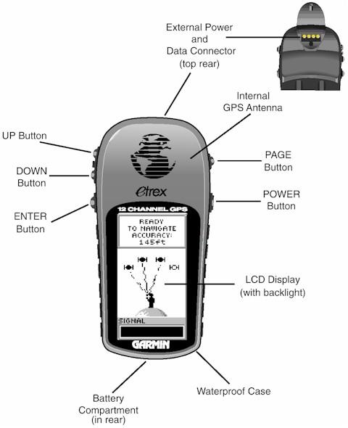
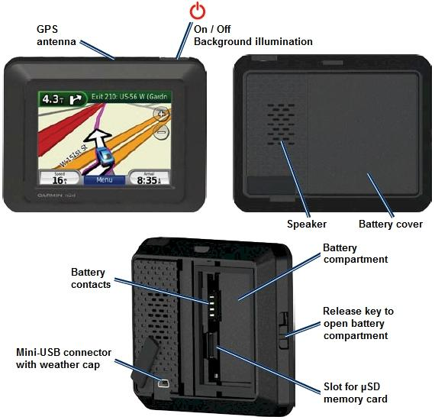
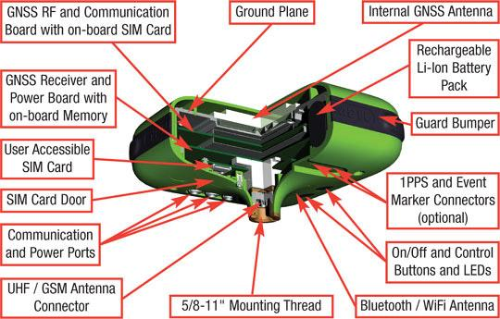
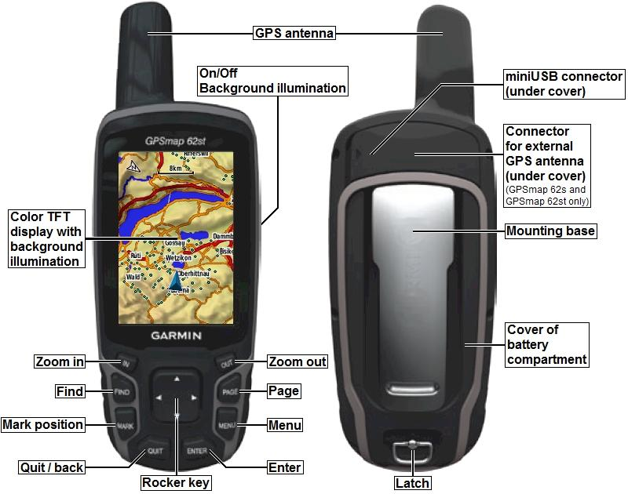
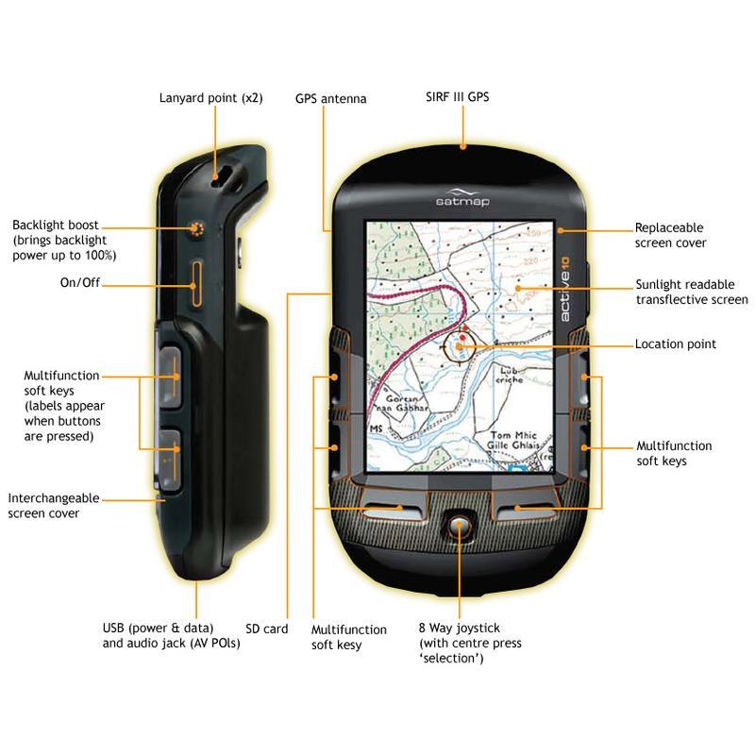
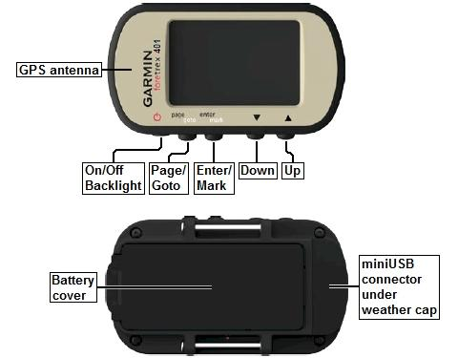
A typical GPS receiver consists of:
- GPS/GNSS antenna
- Signal receiver
- Processor
- Display or interface
- Battery or power supply
- Memory/storage
- Communication ports (USB, Bluetooth, Wi-Fi on some models)

Types of GPS Receivers

1. Handheld GPS Receiver
# Source: AI Source: Provided by: [Data Path: Persons Table -> ID Column: 1, Name_En Column: Motasem Essam] -> From: [ChatGPT] on [7/17/2026]
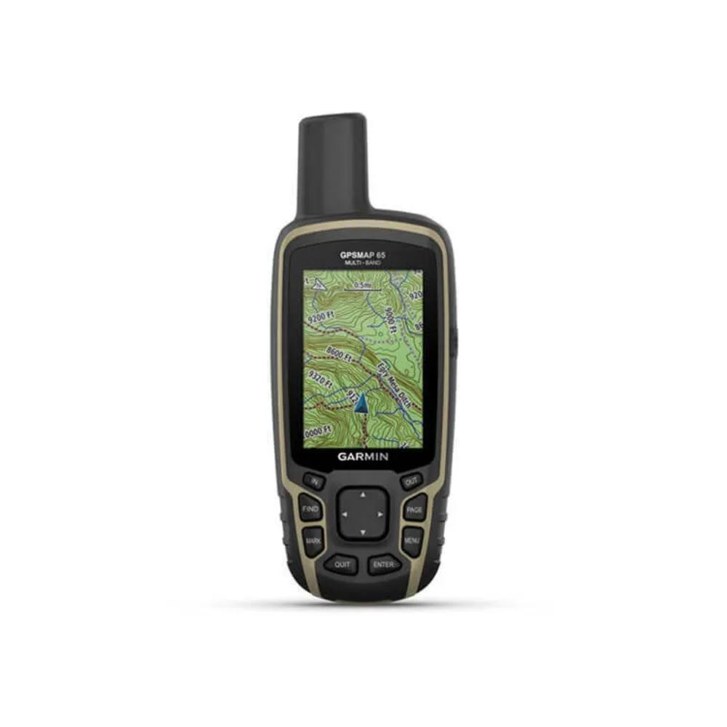
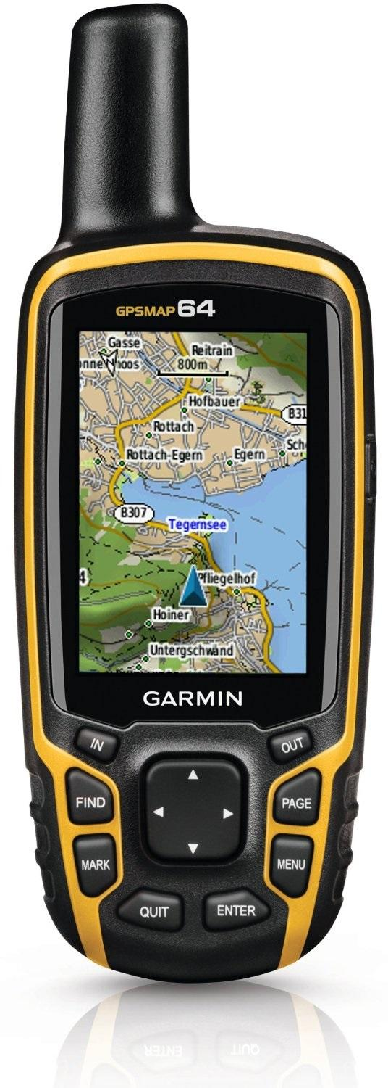
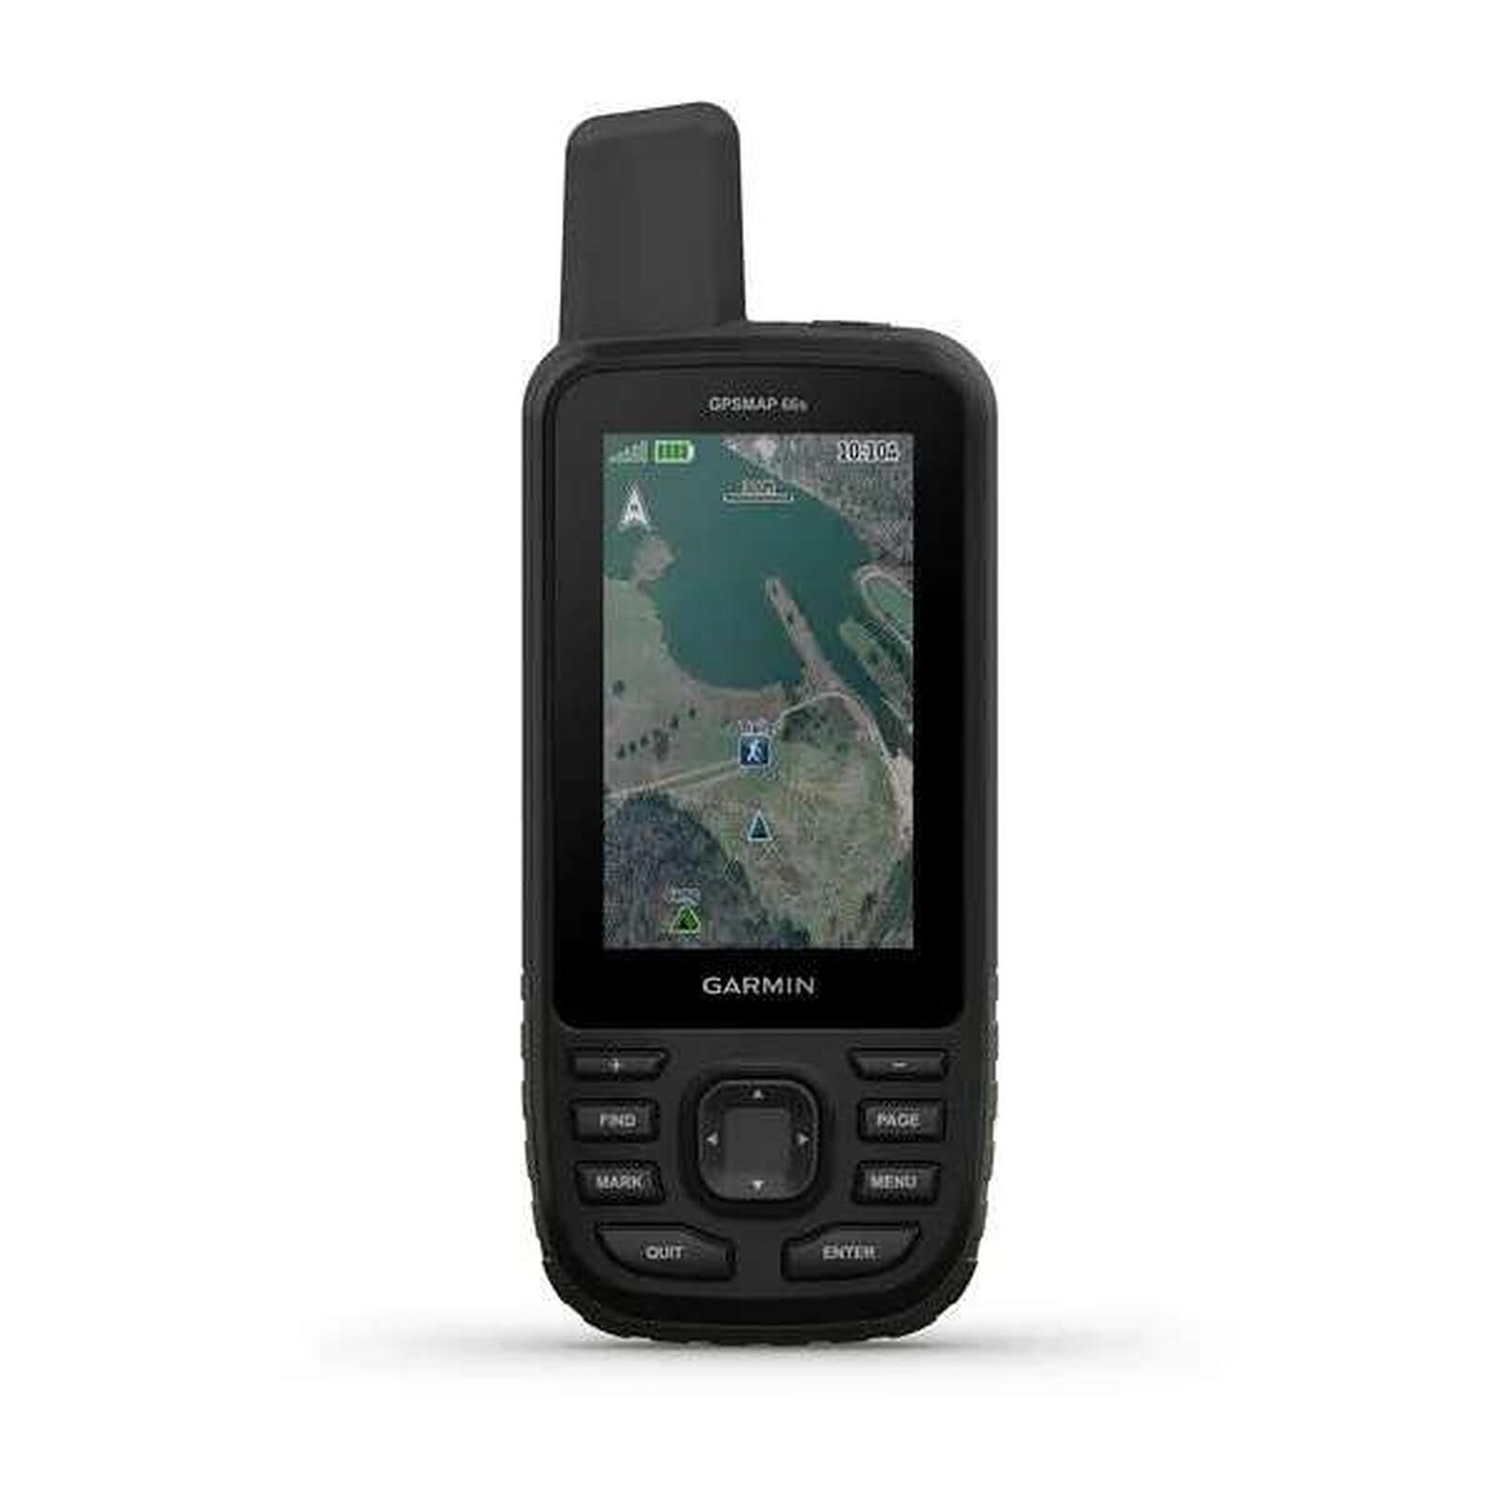
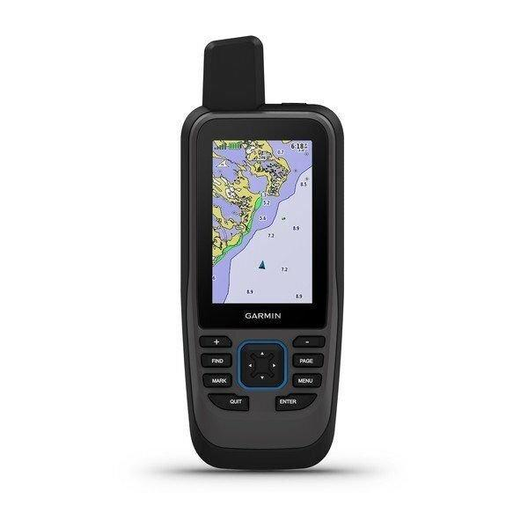
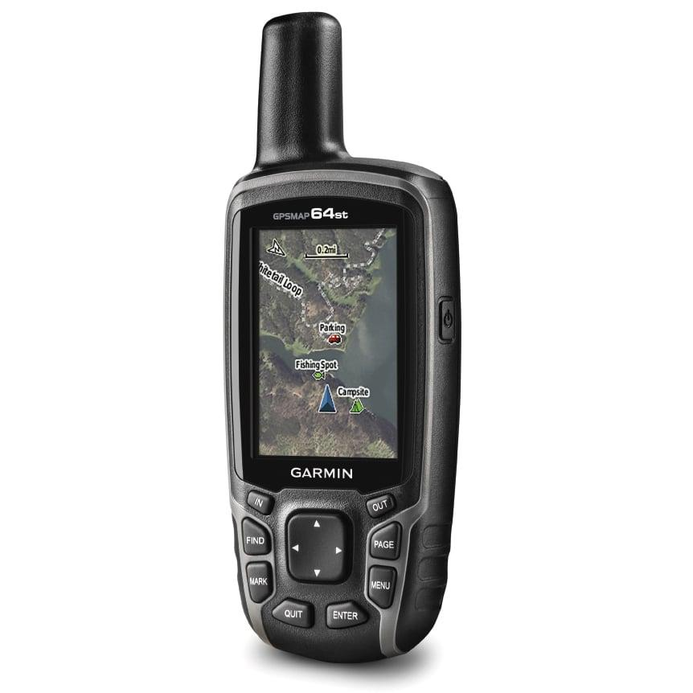
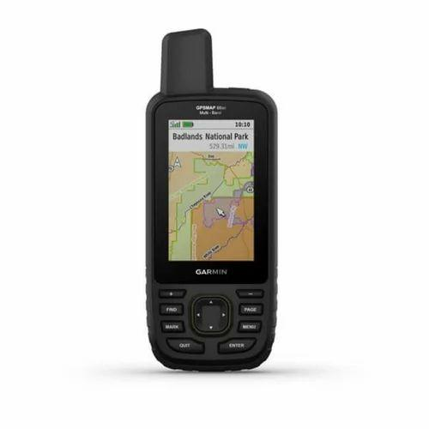
Description
Portable GPS receiver designed for outdoor navigation.
Applications
- Hiking
- Camping
- Field surveying
- Search and rescue

2. Automotive GPS Receiver
# Source: AI Source: Provided by: [Data Path: Persons Table -> ID Column: 1, Name_En Column: Motasem Essam] -> From: [ChatGPT] on [7/17/2026]

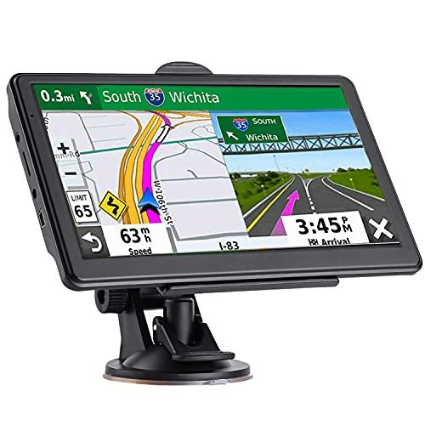
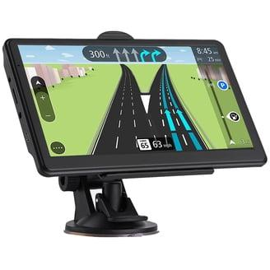
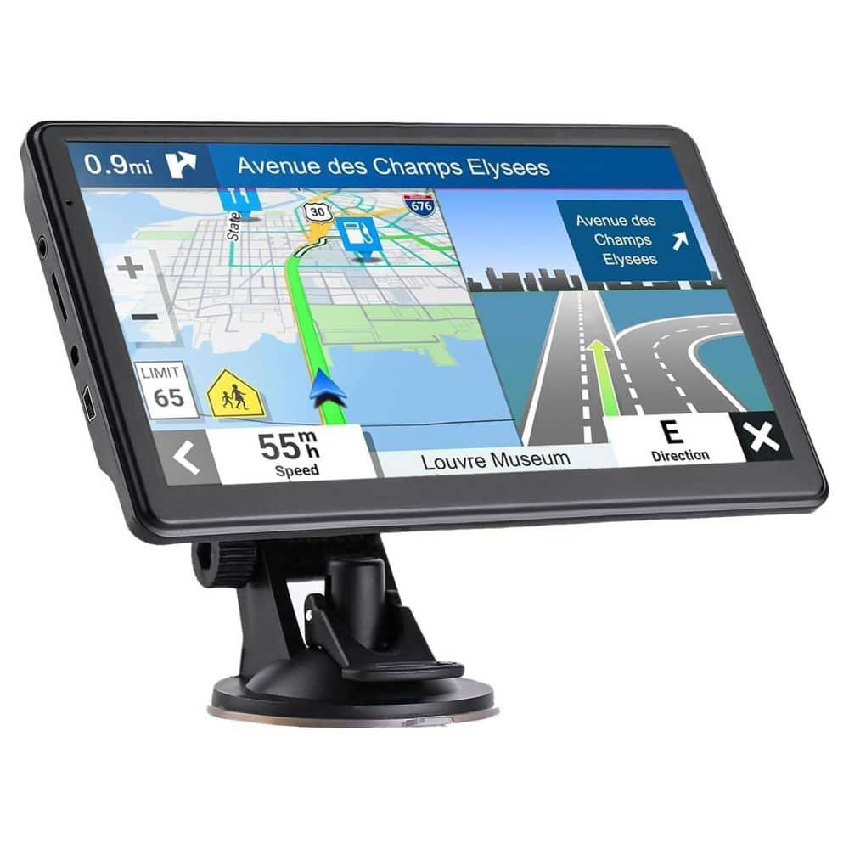
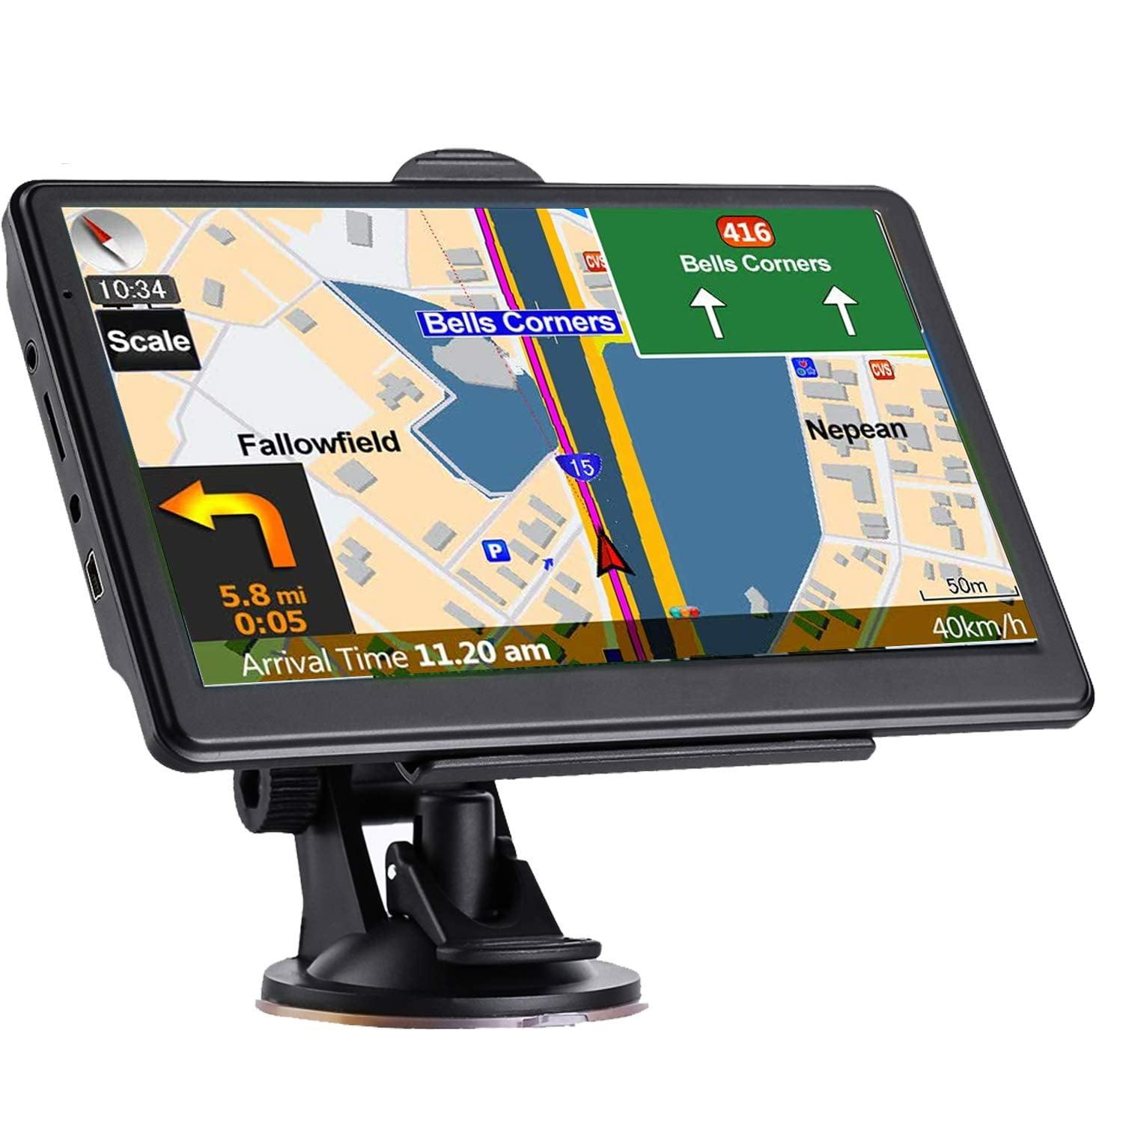
Description
Vehicle navigation device that provides position, route guidance, and speed information.
Applications
- Cars
- Trucks
- Fleet management

3. Marine GPS Receiver
# Source: AI Source: Provided by: [Data Path: Persons Table -> ID Column: 1, Name_En Column: Motasem Essam] -> From: [ChatGPT] on [7/17/2026]
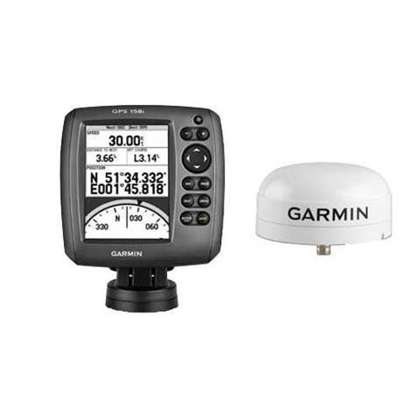
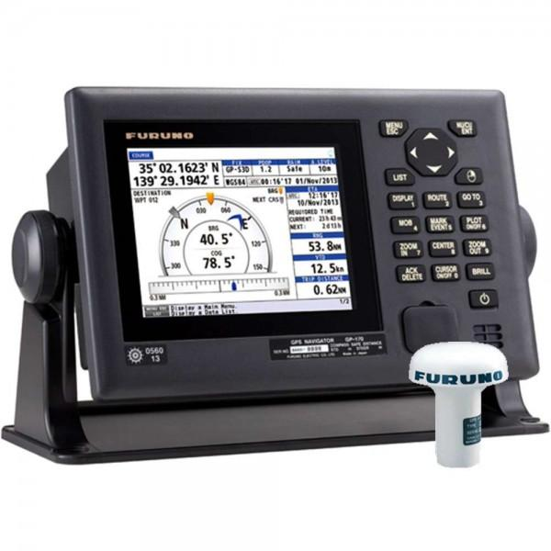
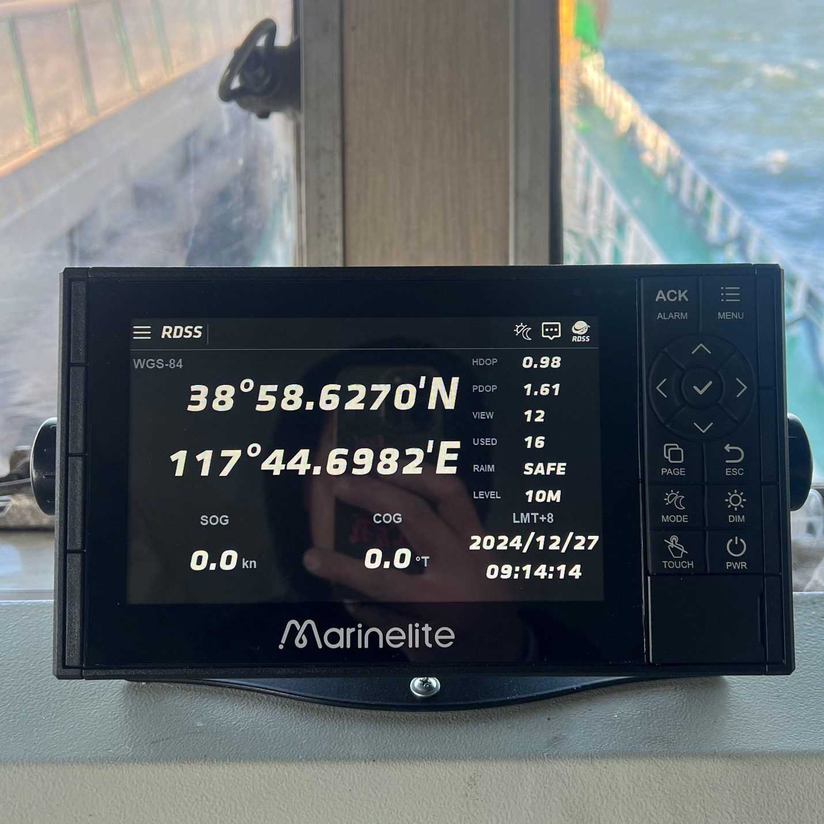
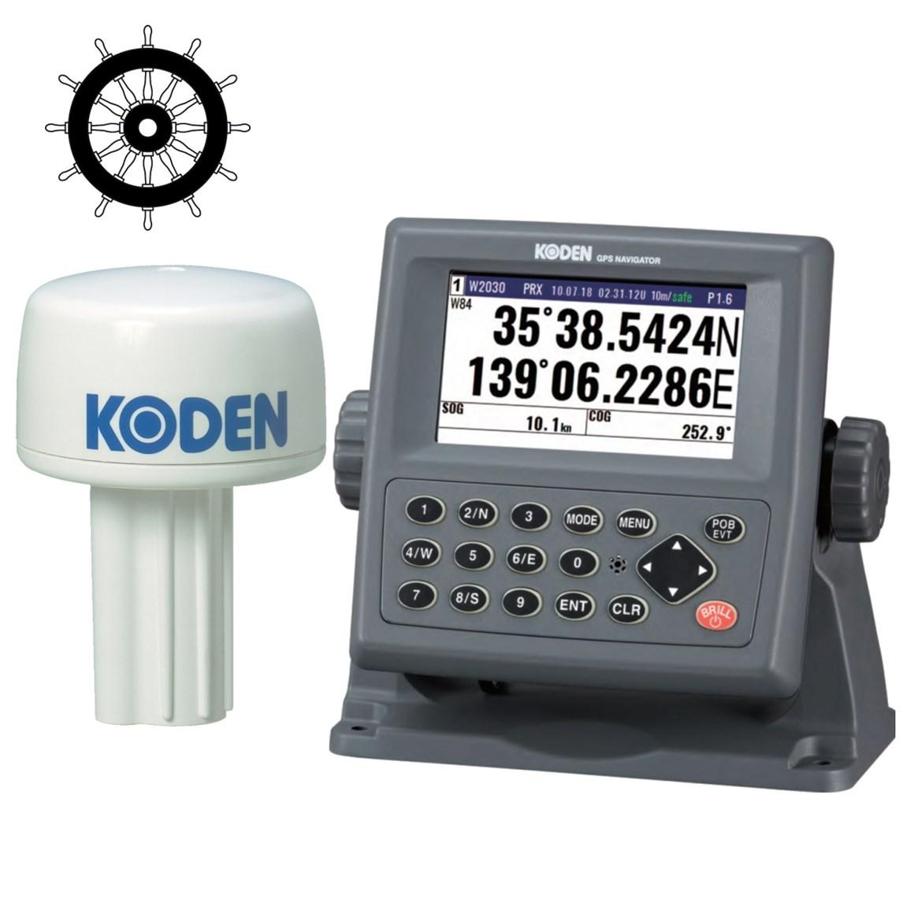
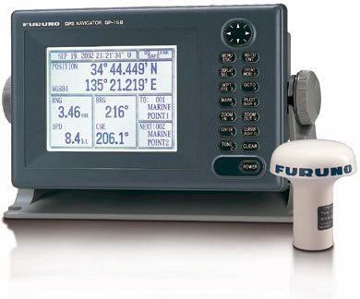
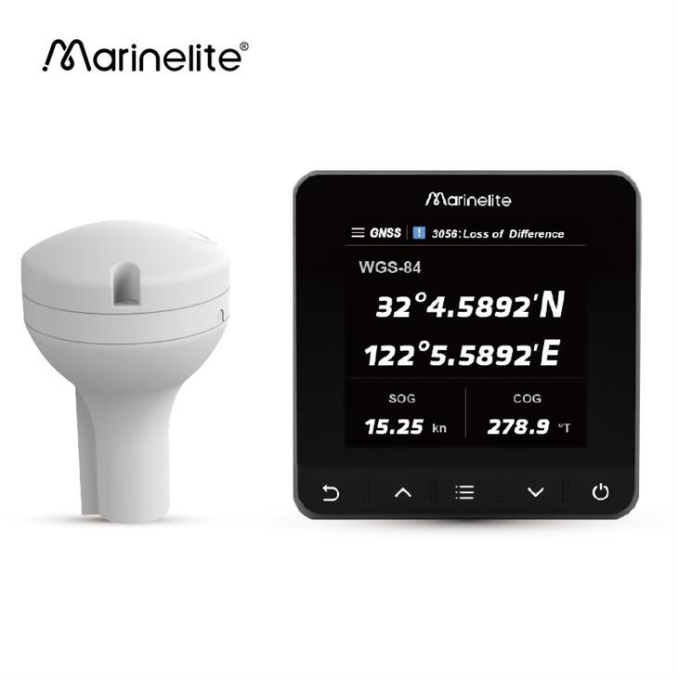
Description
Waterproof GPS receiver designed for marine navigation.
Applications
- Boats
- Ships
- Fishing
- Marine surveying

4. Survey-Grade GNSS Receiver
# Source: AI Source: Provided by: [Data Path: Persons Table -> ID Column: 1, Name_En Column: Motasem Essam] -> From: [ChatGPT] on [7/17/2026]
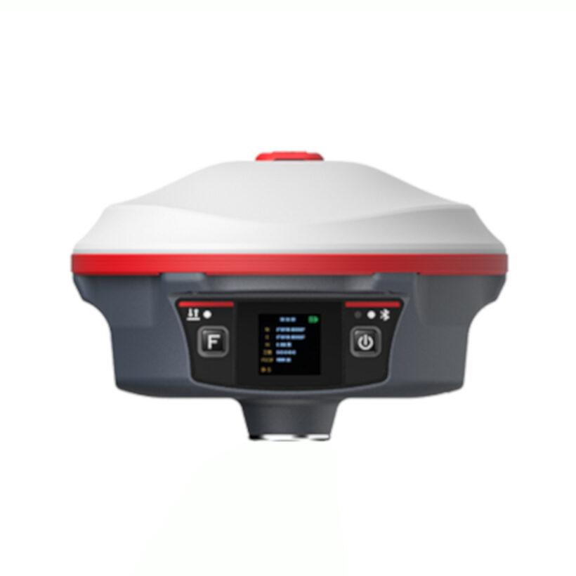
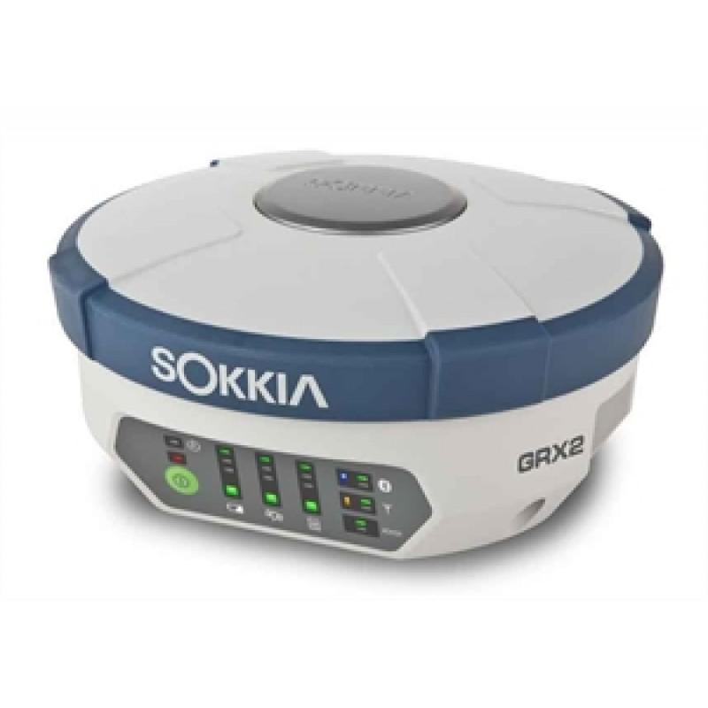
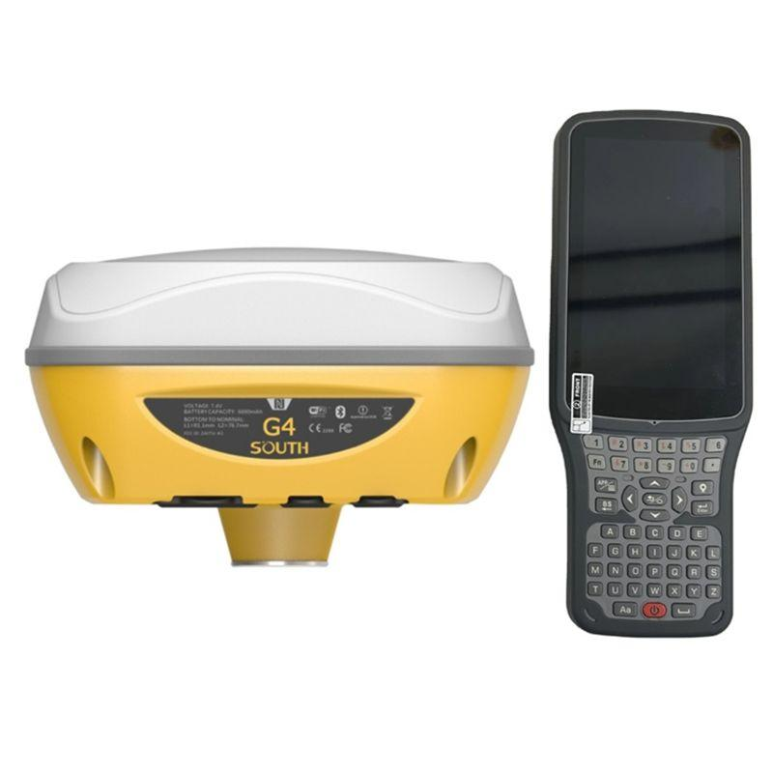
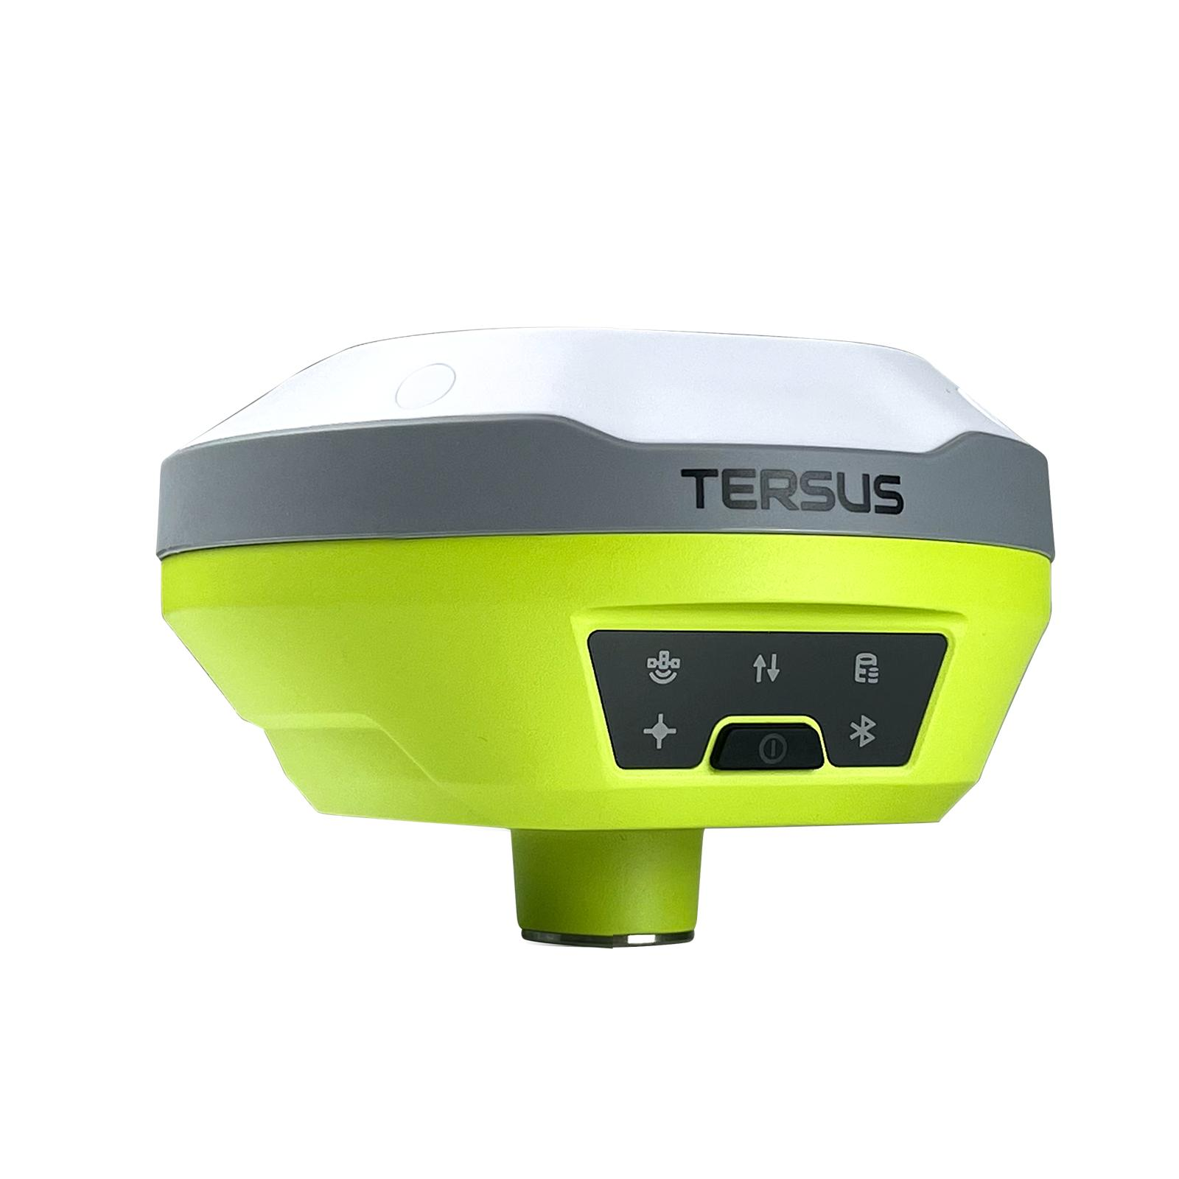
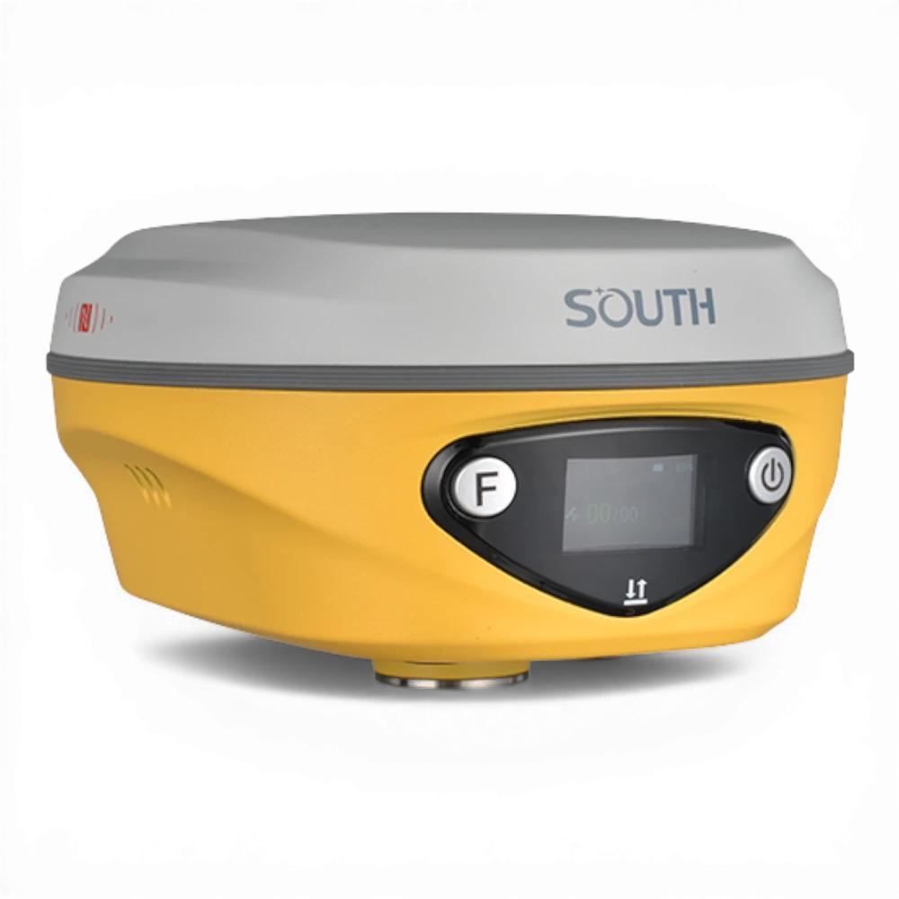
Description
High-precision GPS/GNSS receiver capable of centimeter-level positioning.
Applications
- Land surveying
- Construction
- Geodesy
- Precision agriculture

Measuring Units
# Source: AI Source: Provided by: [Data Path: Persons Table -> ID Column: 1, Name_En Column: Motasem Essam] -> From: [ChatGPT] on [7/17/2026]
A GPS receiver typically displays speed in:
- Meters per second (m/s)
- Kilometers per hour (km/h)
- Miles per hour (mph)
- Knots (kn)

Measuring Range
# Source: AI Source: Provided by: [Data Path: Persons Table -> ID Column: 1, Name_En Column: Motasem Essam] -> From: [ChatGPT] on [7/17/2026]
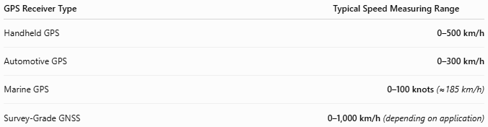
GPS Receiver Type | Typical Speed Measuring Range
Handheld GPS | 0–500 km/h
Automotive GPS | 0–300 km/h
Marine GPS | 0–100 knots (≈185 km/h)
Survey-Grade GNSS | 0–1,000 km/h (depending on application)

Resolution
# Source: AI Source: Provided by: [Data Path: Persons Table -> ID Column: 1, Name_En Column: Motasem Essam] -> From: [ChatGPT] on [7/17/2026]
Resolution is the smallest speed increment displayed.
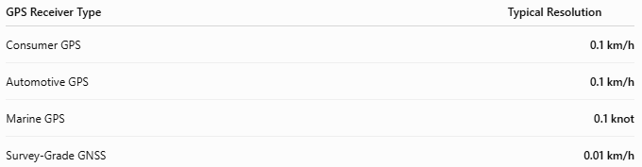
GPS Receiver Type | Typical Resolution
Consumer GPS | 0.1 km/h
Automotive GPS | 0.1 km/h
Marine GPS | 0.1 knot
Survey-Grade GNSS | 0.01 km/h

Accuracy
# Source: AI Source: Provided by: [Data Path: Persons Table -> ID Column: 1, Name_En Column: Motasem Essam] -> From: [ChatGPT] on [7/17/2026]
Accuracy depends on satellite visibility, signal quality, and receiver technology.
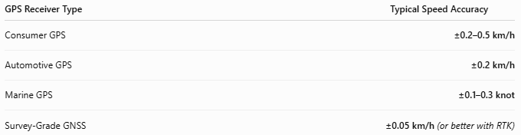
GPS Receiver Type | Typical Speed Accuracy
Consumer GPS | ±0.2–0.5 km/h
Automotive GPS | ±0.2 km/h
Marine GPS | ±0.1–0.3 knot
Survey-Grade GNSS | ±0.05 km/h (or better with RTK)
Notes
- GPS measures ground speed, not wheel or engine speed.
- Speed accuracy is often better than position accuracy because it is derived from Doppler measurements.
- Survey-grade receivers using RTK (Real-Time Kinematic) corrections can achieve extremely high precision.

How to Use a GPS Receiver
# Source: AI Source: Provided by: [Data Path: Persons Table -> ID Column: 1, Name_En Column: Motasem Essam] -> From: [ChatGPT] on [7/17/2026]
- Turn on the receiver.
- Wait until satellite signals are acquired.
- Allow the position to stabilize.
- Begin moving.
- Read the displayed speed and location.

Applications
# Source: AI Source: Provided by: [Data Path: Persons Table -> ID Column: 1, Name_En Column: Motasem Essam] -> From: [ChatGPT] on [7/17/2026]
GPS receivers are used in:
- Navigation
- Fleet management
- Aviation
- Marine navigation
- Surveying
- Mapping
- Sports tracking
- Precision agriculture
- Emergency response

Advantages
# Source: AI Source: Provided by: [Data Path: Persons Table -> ID Column: 1, Name_En Column: Motasem Essam] -> From: [ChatGPT] on [7/17/2026]
A GPS receiver:
- Measures speed without physical contact.
- Provides real-time location and navigation.
- Works over very long distances.
- Offers high speed accuracy.
- Can store tracks and routes.

Limitations
# Source: AI Source: Provided by: [Data Path: Persons Table -> ID Column: 1, Name_En Column: Motasem Essam] -> From: [ChatGPT] on [7/17/2026]
A GPS receiver:
- Requires satellite visibility.
- Accuracy decreases near tall buildings, mountains, or dense forests.
- May experience delays in tunnels or indoors.
- Depends on battery power.

Sources of Error
# Source: AI Source: Provided by: [Data Path: Persons Table -> ID Column: 1, Name_En Column: Motasem Essam] -> From: [ChatGPT] on [7/17/2026]
Receiver Errors
- Poor antenna quality
- Outdated firmware
- Low battery

User Errors
- Incorrect setup
- Obstructing the antenna
- Using indoors

Environmental Errors
- Signal blockage
- Atmospheric interference
- Multipath reflections from buildings
- Severe weather (minor effect)

Comparison with Other Speed Measuring Instruments
# Source: AI Source: Provided by: [Data Path: Persons Table -> ID Column: 1, Name_En Column: Motasem Essam] -> From: [ChatGPT] on [7/17/2026]
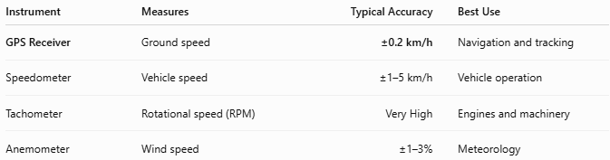
Instrument | Measures | Typical Accuracy | Best Use
GPS Receiver | Ground speed | ±0.2 km/h | Navigation and tracking
Speedometer | Vehicle speed | ±1–5 km/h | Vehicle operation
Tachometer | Rotational speed (RPM) | Very High | Engines and machinery
Anemometer | Wind speed | ±1–3% | Meteorology

Care and Maintenance
# Source: AI Source: Provided by: [Data Path: Persons Table -> ID Column: 1, Name_En Column: Motasem Essam] -> From: [ChatGPT] on [7/17/2026]
To maintain performance:
- Keep the antenna unobstructed.
- Update firmware regularly.
- Charge the battery fully.
- Protect the device from moisture and impacts.
- Store in a protective case when not in use.

Common Mistakes
# Source: AI Source: Provided by: [Data Path: Persons Table -> ID Column: 1, Name_En Column: Motasem Essam] -> From: [ChatGPT] on [7/17/2026]
- Using the receiver indoors.
- Blocking the antenna.
- Assuming instant position lock.
- Ignoring poor satellite reception warnings.

Key Points
# Source: AI Source: Provided by: [Data Path: Persons Table -> ID Column: 1, Name_En Column: Motasem Essam] -> From: [ChatGPT] on [7/17/2026]
- GPS stands for Global Positioning System.
- A GPS receiver measures ground speed, position, direction, and time.
- Common types:
  - Handheld GPS Receiver
  - Automotive GPS Receiver
  - Marine GPS Receiver
  - Survey-Grade GNSS Receiver
- Modern receivers often support multiple GNSS constellations for improved accuracy.

Conclusion
# Source: AI Source: Provided by: [Data Path: Persons Table -> ID Column: 1, Name_En Column: Motasem Essam] -> From: [ChatGPT] on [7/17/2026]
A GPS Receiver is a versatile electronic navigation instrument that determines speed, location, and direction using signals from navigation satellites. Its ability to provide accurate, real-time measurements without physical contact makes it an essential tool for navigation, surveying, transportation, mapping, outdoor recreation, and industrial applications.

